Lab 4 - Network Scanning

1. NMAP

1. Open a linux terminal
2. Simply type “nmap” and take note of the syntax and available options

Ans: 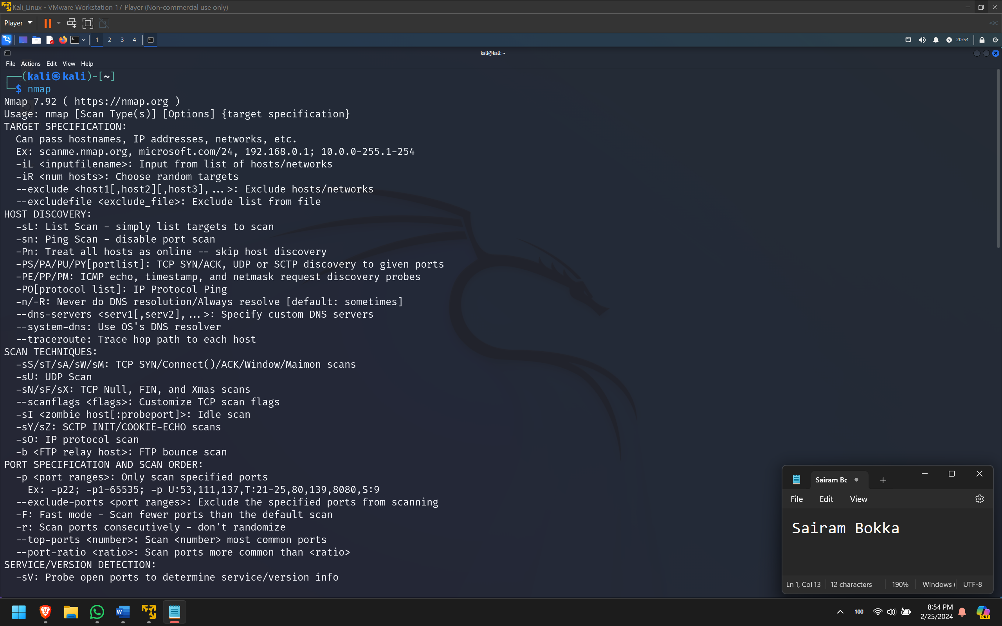

1. Perform a simple ping scan of your Kali VM (via localhost address or IP address) and note what information do you get back.

Ans: 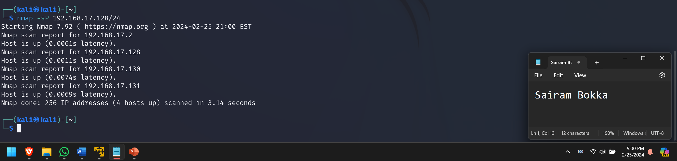

Simple ping scan reveals 4 hosts are up on this machine.

1. Perform a TCP Connect scan of your Kali VM (via localhost address or IP address) and note what information you get back.

Ans: 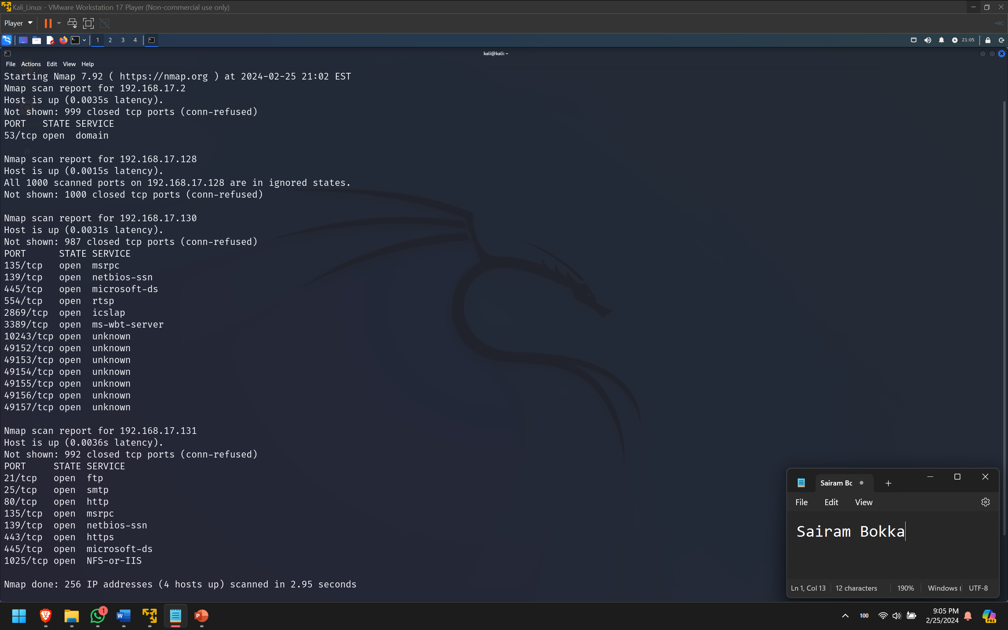  
TCP scan shows details about the open ports on windows 7 and windows XP machines.

1. Perform a TCP Connect scan with version identification of your Kali VM (via localhost address or IP address) and note what information do you get back?

Ans: 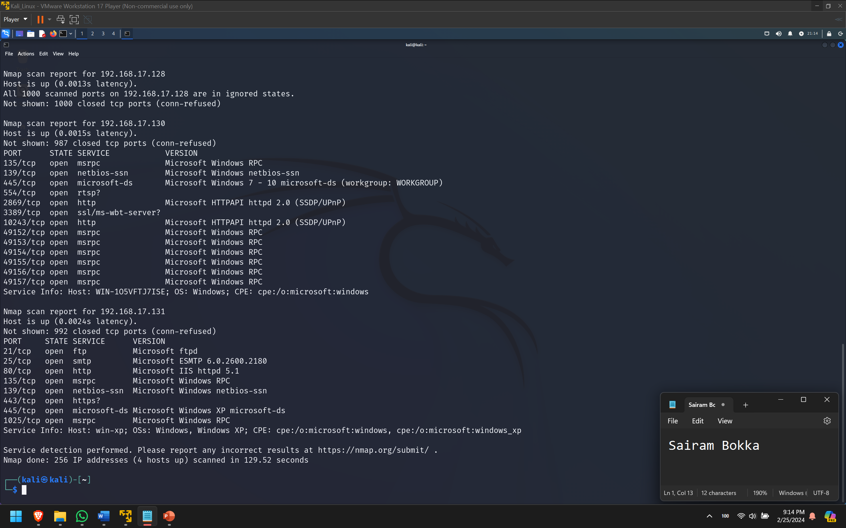

Version identification enabled the nmap scan to find exact version of the services running on open ports of the Windows VMs.

1. Perform an Aggressive TCP Connect scan across the entire virtual network range and note the results.

Ans: 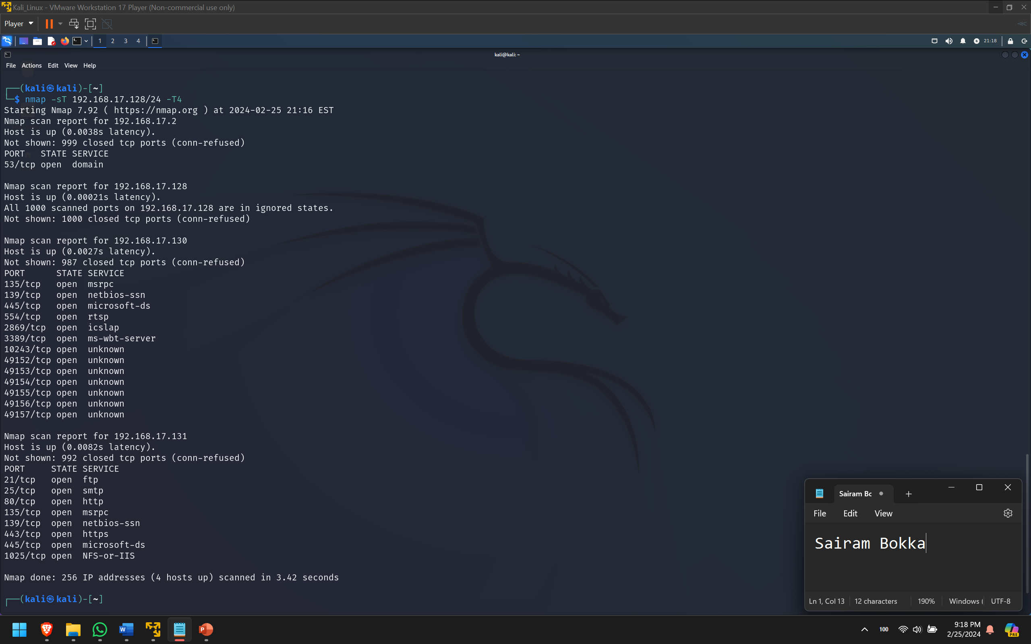

1. Perform a Paranoid TCP SYN scan against a specific target. (Let it run for a couple minutes, then you can kill the scan by typing "Ctrl-C" - This is just to let you experience the slowness of the scan)

Ans: 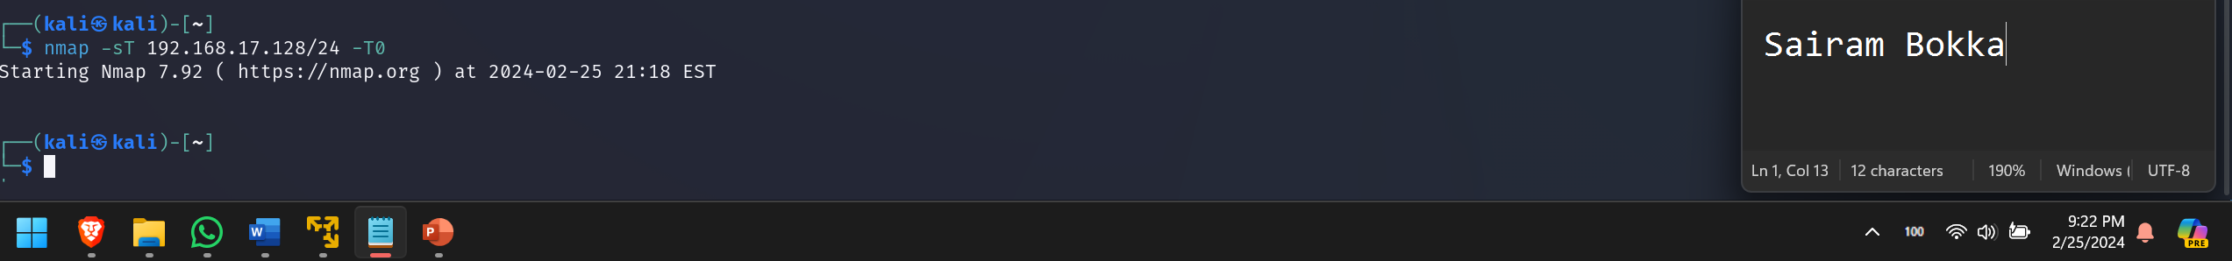

1. Perform a Normal TCP SYN scan with version identification on a specific target and output to a file

Ans: 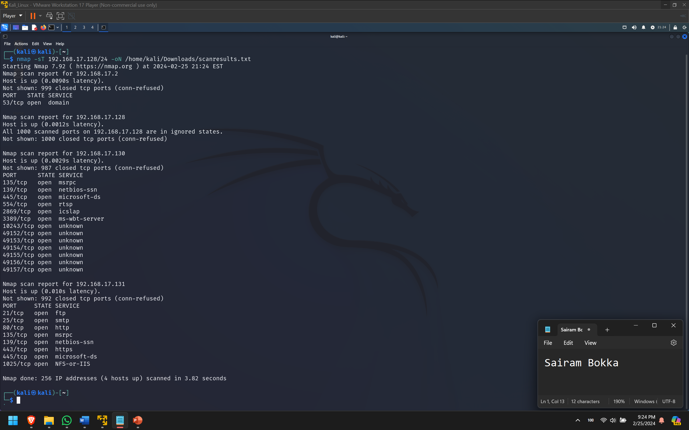

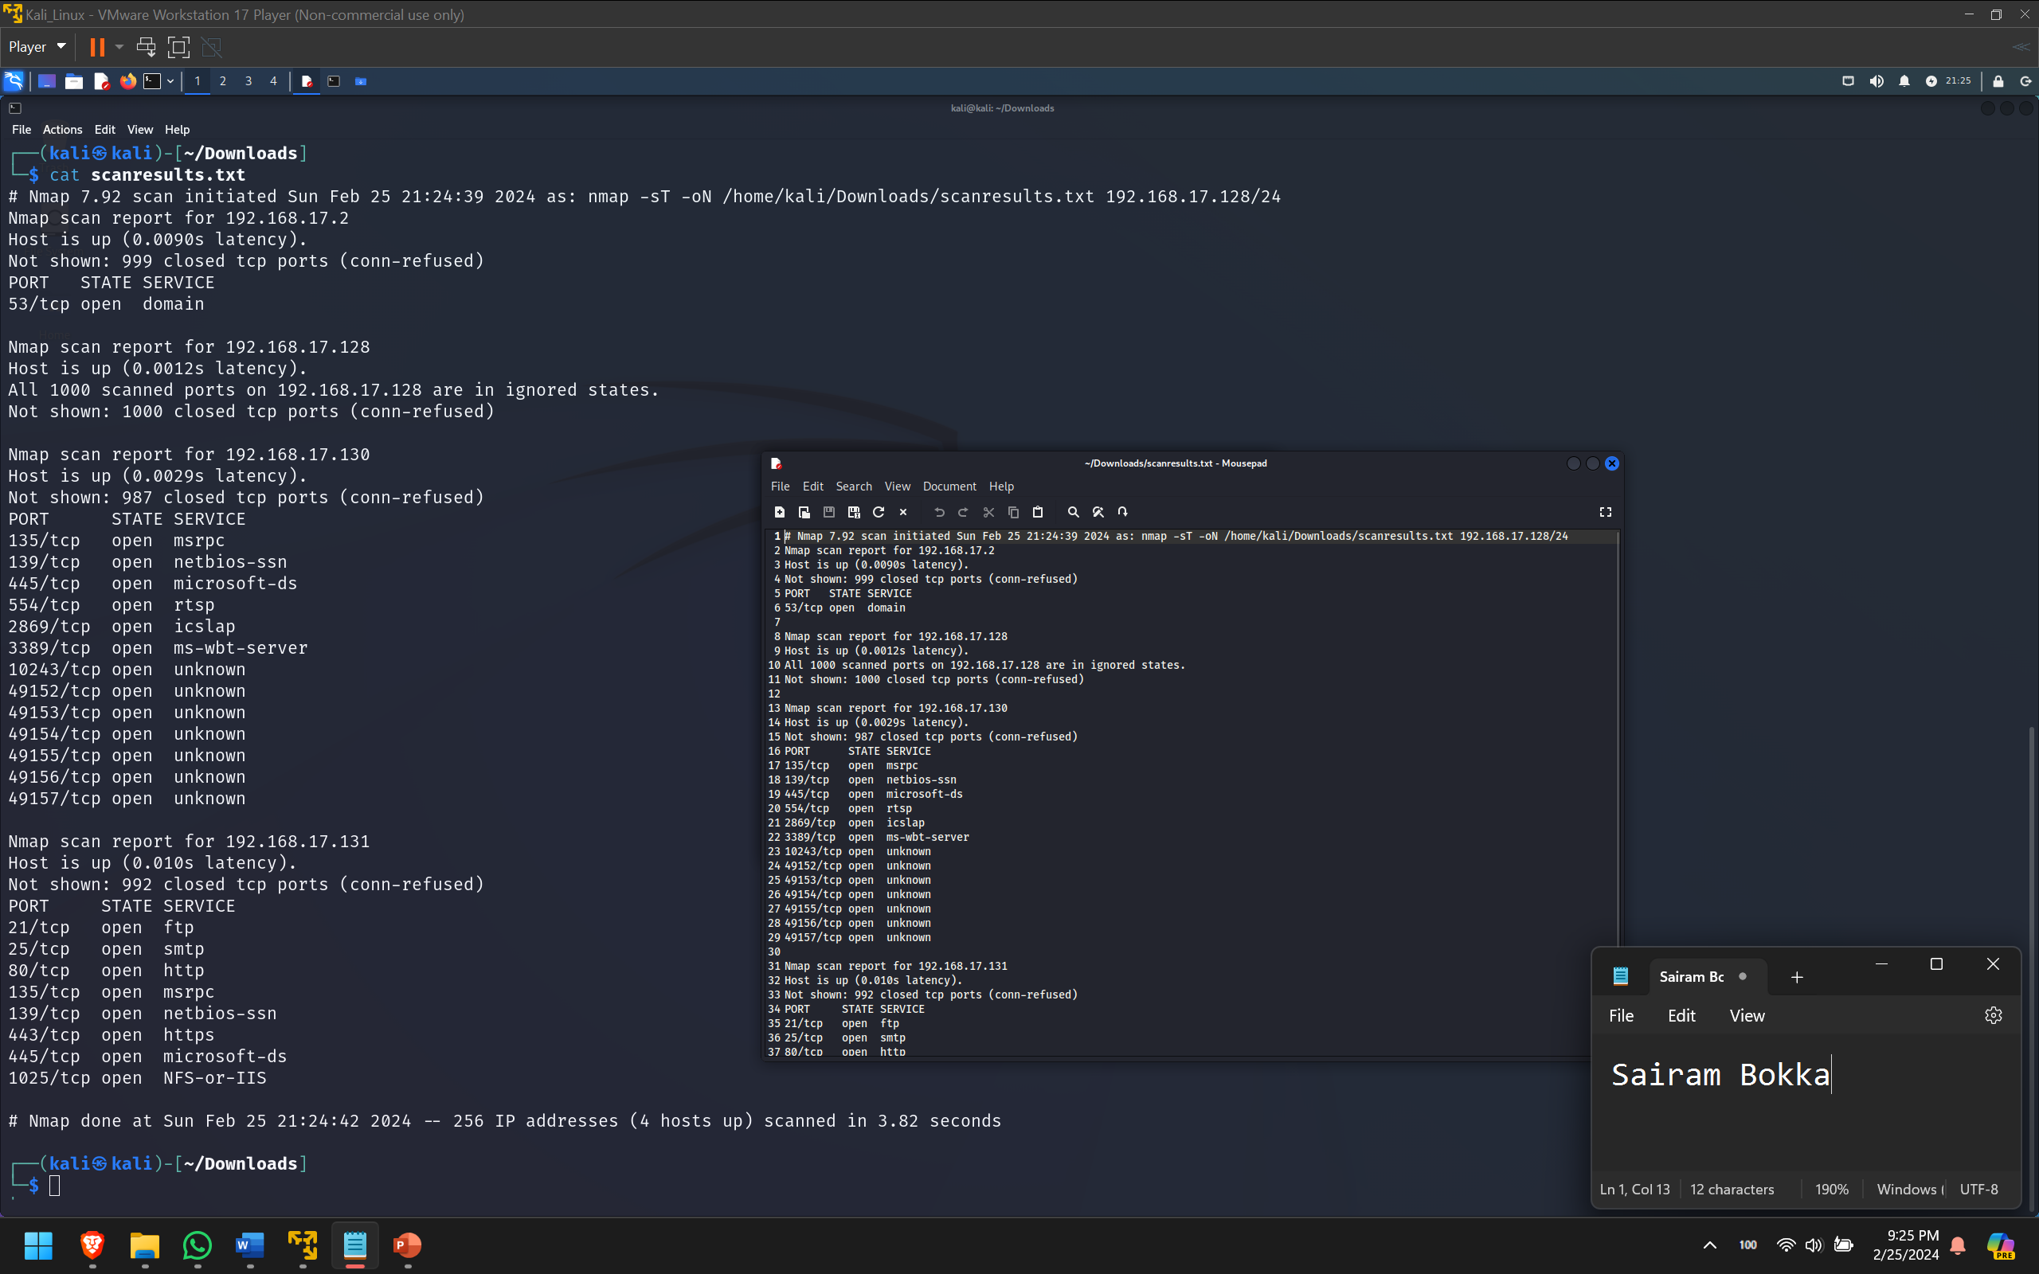

2. Zenmap

1. Open ZenMap and in the target window, type in the network address of the virtual network on your system.
2. In the Profile drop down, select Ping scan
3. Note the “Command” shown

Ans: 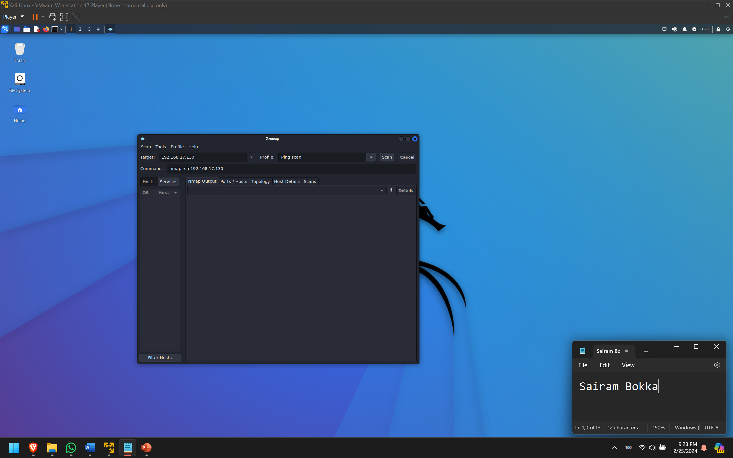

1. Press the “Scan” button
2. Take note of the results

Ans: 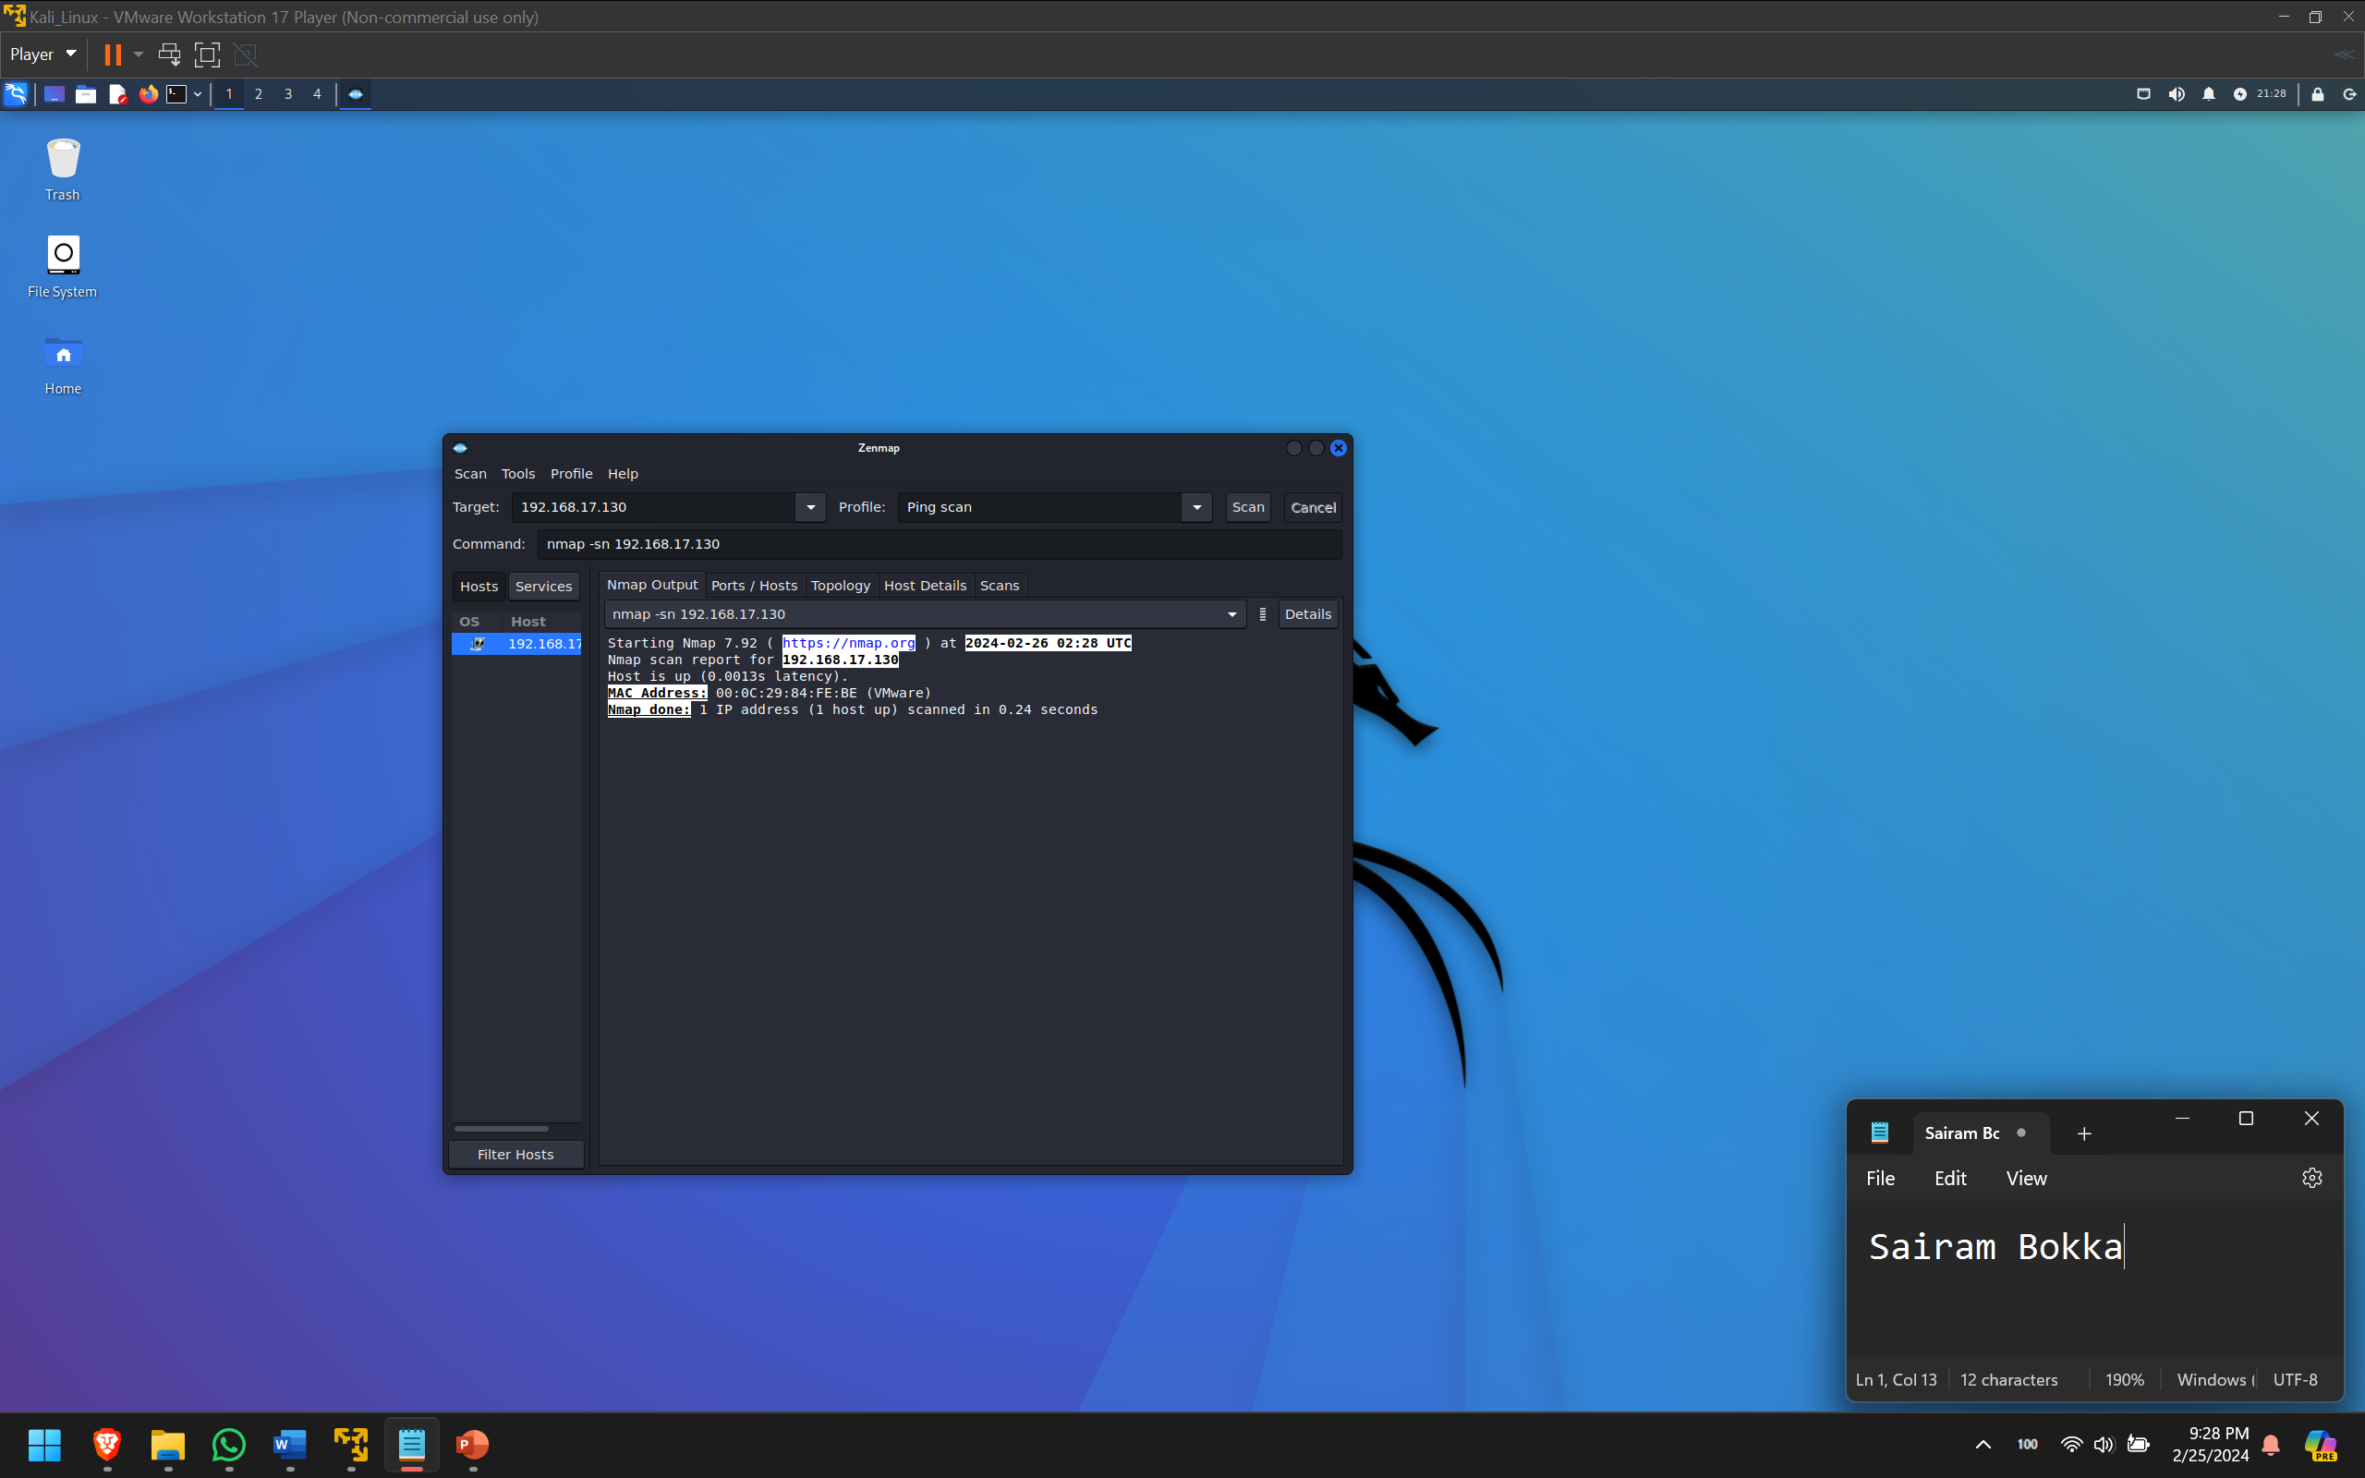

1. Perform a slow comprehensive scan on a select target
2. As with the Ping scan, note the “Command” shown
3. Take note of the results and the time it takes to get them

Ans: 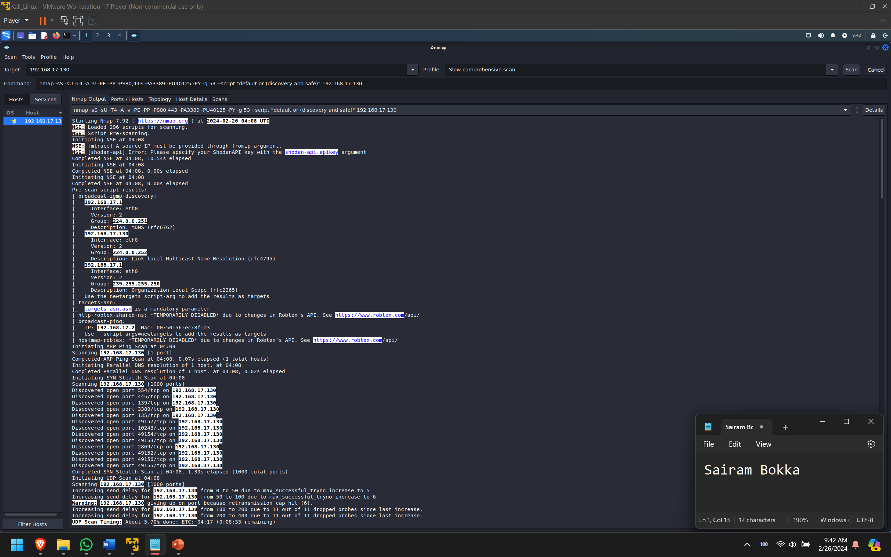

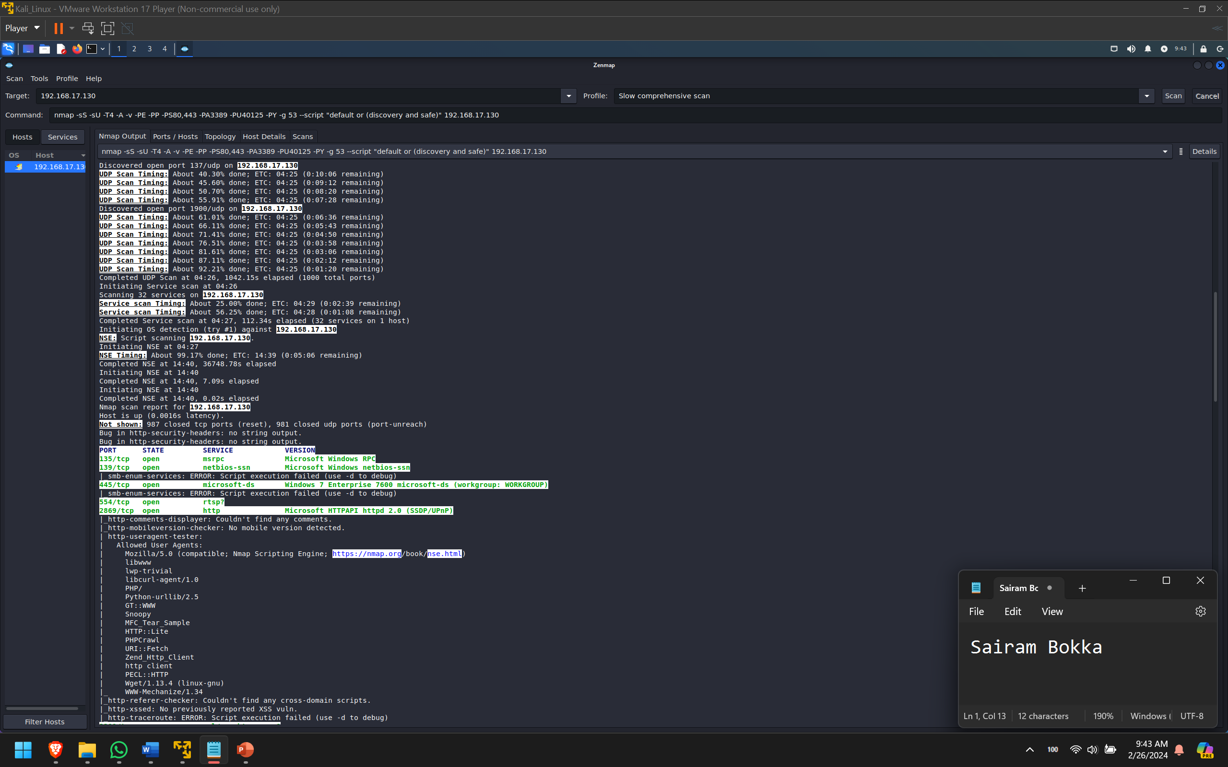

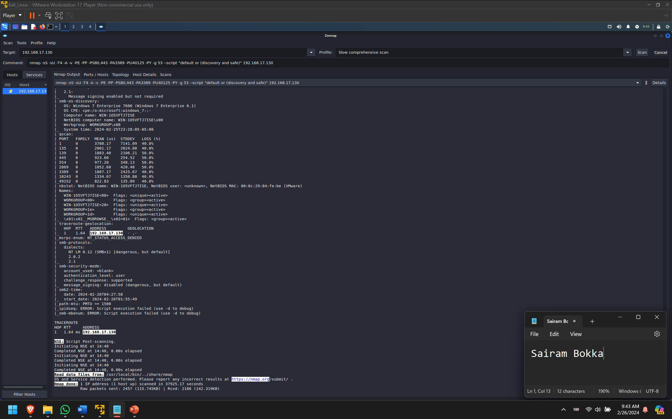

It took about an hour to complete the slow comprehensive scan.

1. Perform an intense scan on the same target you selected above
2. As with the previous scans, note the “Command” shown
3. Take note of the results and the time it takes to get them

Ans: 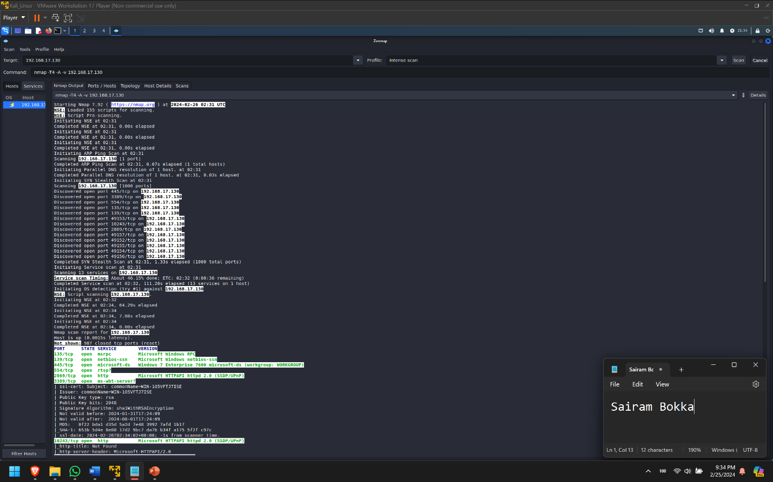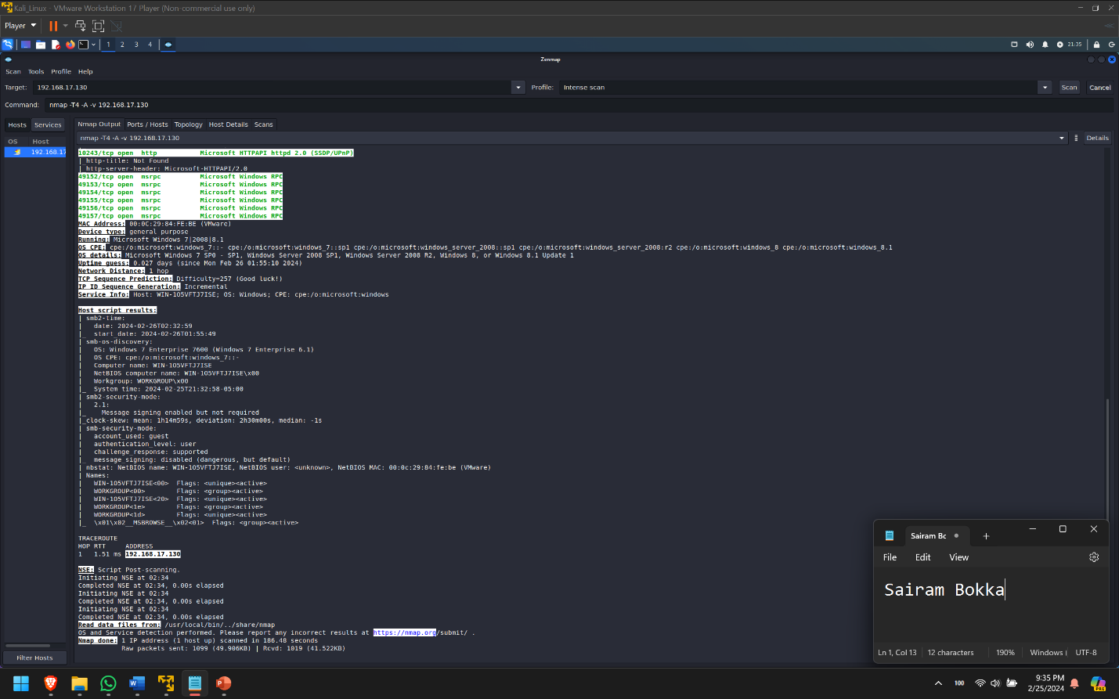

It takes about 3 minutes to complete an intense scan.